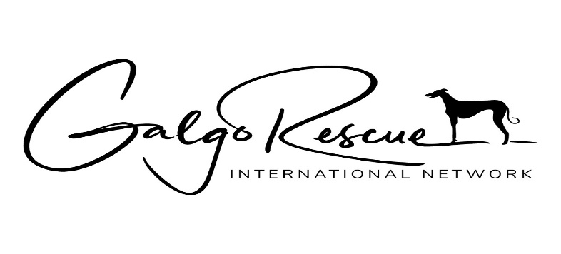
Adoption Application
Ownership of a Galgo is a serious responsibility requiring a long-term commitment. This application has been designed to evaluate potential adopters and address the suitability and permanence of each Galgo placed in a home.
Name(s)……………………………………………………………………………………………………………………………………………. Street address…………………………………………………………………………………………………………………………………... City……………………………………………………………………………..State…………………..Zipcode…………………………… Phone: Cell……………………………………………….Work………………………………Landline…………………………………. Email address(es):……………………………………………………………………………………………………………………………… Preferred method of contact (please circle): cell text email landline
Mailing address (if different from above):…………………………………………………………….…………………………………. Applicant(s) occupation(s)………………………………………………………………………………………………………………..
How did you hear about Galgo Rescue International Network?............................................................
Why do you want to adopt a galgo?........................................................................................................ Occasionally an older Galgo or one with special needs is available. Would you consider adopting such a /
Do you live in a single family home ……… Condominium …….. Apartment ..…..Duplex ……..Mobile home?
Do you ……..Own …….Rent?
If you rent, please provide the landlord’s contact information:
Name(s)……………………………………………………………………………………………………………………………………………. Street address…………………………………………………………………………………………………………………………………... City……………………………………………………………………………..State…………………..Zipcode…………………………… Phone: Cell……………………………………………….Work………………………………Landline…………………………………. Email address(es):………………………………………………………………………………………………………………………………
If you live in a covenant controlled/restricted community please provide contact info for the governing body:……………………………………………………………………………………………………………………………………………………
Will the galgo have access to a yard? Yes No Is the yard completely fenced : Yes No
Please describe the type of fence and its height…………………………………………………………………………
Does your home have interior or exterior stairs? Yes No
Total number of adults in the household………..Total number of children ……….. Ages…………………
Are additional children planned for the future? Yes No
If children are under eight years old, do you agree to talk with a child/dog mentor before adopting or after adoption should any problems arise? Yes No N/A
Who will be responsible for the care and training of your Galgo?............................................................
Approximately how many hours will your Galgo be alone each day? ………………. If more than 9 hours, what accommodations will be made for the dog’s potty breaks during the day?
………..Doggy door ……….Pet Sitter ………….doggy daycare …………oth
What is the activity level of your household? …..quiet …..moderately active …..active …….very active What arrangements will be made for your Galgo when you travel/are absent for an extended amount of time?.............................................................................................................................................................. What type of exercise will your galgo receive?............................................................................................. Do you currently have a dog(s)? Yes No If yes, please list gender, breed, age and temperament……. ……………………………………………………………………………………………………………………………………………………………. Do you have any other pets? Yes No If yes, please describe…………………………………………………………… Do you plan on adding any other pets, besides the galgo, to the household? Yes No If yes, please Describe:……………………………………………………………………………………………………………………………………………. How many pets have you had in the last 5 years? ………….. Please describe what became of them…… …………………………………………………………………………………………………………………………………………………………… Have you ever adopted a pet from a shelter or rescue group? Yes No Have you ever surrendered an animal to a shelter or rescue group? Yes No. If yes, please describe the circumstances……………………………………………………………………………………………………………………………….. Are you willing and able to spend the funds necessary for pet ownership? Yes No What is your estimated yearly cost of caring for your dog and what does this figure include?......................................................................................................................................................... Do you agree to keep your Galgo leashed at all times, when out-of doors, in an unfenced area? Yes No Do you agree to keep your Galgo as an indoor family pet? Yes No Do you agree not to seclude the Galgo in a garage, basement, laundry room or other area away from the family? Yes No
Where will your Galgo sleep? …………………………………………………………………………………………………………………. Do you agree to keep the buckle collar with the identification tags, including your name and address, rabies tag, and license on your galgo at all times? Yes No
Are you aware of and willing to abide by, at all times, the local ordinances pertaining to animal/pet ownership? Yes No
Do you agree to immediately notify Galgo Rescue International Network, Inc.
Do you agree to immediately notify Galgo Rescue International Network, Inc. should your Galgo become lost or stolen? Yes No
Do you agree to contact Galgo Rescue International Network, Inc. if you unable or unwilling to keep your Galgo? Yes No
Do you agree that if you need to surrender your Galgo that you make arrangements to return the dog to the Denver metro area? Yes No
Do you have a veterinarian? Yes No Is your veterinarian familiar with the special medical requirements of sighthounds? Yes No
Your veterinarian’s name, address and phone number:………………………………………………………………………… Are you willing and able to pick up your Galgo from its arrival destination in the USA? Yes No (Unless other arrangements have been made in advance)
Upon receiving your galgo, do you agree to be responsible for any and all medical costs of your Galgo unless prior arrangements have been made? Yes. No
Please list a personal reference, not a relative or household member that you have known for at least three years: ……………………………………………………………………………………………………………………………………
I agree to a home visit to be conducted by a trained Galgo Rescue International Network volunteer
Yes No
I agree to keep and maintain the tracking device on the Galgo’s collar until I feel secure that he/she is not a flight risk. Yes No
I understand and agree to the need for screening adopters. I certify that the information supplied on this application is true and correct. Yes No
Signature(s)……………………………………………………………………………………………………..Date……………………….
Any additional information:
………………………………………………………………………………………………………………………………………………………………
……………………………………………………………………………………………………………………………………………………………..
……………………………………………………………………………………………………………………………………………………………..
……………………………………………………………………………………………………………………………………………………………..
G.R.I.N. is a 501 (c) (3) non-profit animal welfare organization run entirely by volunteers.
www.galgorescue.org – Please return completed form to wally@galgorescue.org

